**Excel Assignment - 16**

**1. What is a Macro? How is it useful in excel or in your daily work?**

Ans: Excel Macro is a record and playback tool that simply records your steps and Macro will play it back as many times as you want.

VBA Macros save time as they automate repetitivetasks.

In laymans’s language , a macro is defined as a recording of your routine steps in excel that you can replay using a single button.

**2. What is VBA? Write its full form and briefly explain why VBA is used in excel**

VBA (visual Basic for Application ) is a human –readable and editable Programming Code that gets generated when you record a macro . Toady, it is widly used with other Microsoft office application such as MS-Word, Ms_Excel

VBA is often used to create macros, automate processes, generate custom forms, or perform repetitive tasks that may need minimal human intervention.

**3.How do you record a macro? Write detailed steps to create a macro to automatically make the following table in bold and to create borders for it in excel.**

**hi 78**

**hello 69**

**ineuron 45**

**Recording a macro will record all the action you do on the sheet, whether its itlic, Bold , under line, Border,sorting, filtering etc. everything what ever you do it will record in the VBA script at the backend in theform of macro**

**Go to Developer Tab > Use Relative Reference > Record Macro > give Micro , shotcut Key for macr, description > Ok > record will start you will see stop recording icon > stop recording > Go To Macro > Run**

**Recording a Macro in Excel**

1. Click the Developer tab.
2. In the Code group, click on the Macro button. ...
3. In the Record Macro dialog box, enter a name for your macro. ...
4. (Optional Step) You can assign a keyboard shortcut if you want. ...
5. In the 'Store macro in' option, make sure 'This Workbook' is selected.

**4. What do you mean when we say VBA Editor**

**Abbreviated as VBE, Visual Basic Editor is the tool used to create, modify and maintain Visual Basic for Applications (VBA)**

**VBA Editor is a place where we write**[**VBA code**](https://www.educba.com/vba-code/)**and create macros. Whatever the code we write will be in the background to the excel file with which it is linked, and once we run the code, every process will happen in the background and what we see is the output in the excel file. We always need to activate VBA Editor when we want to see that. And there are many ways to do it**

**5. Briefly describe the interface of a VBA editor? What is properties window? And what is watch window? How do you display these windows**

1. Click the Developer tab.
2. Click the Visual Basic button in the Code group on the Developer tab. This opens the VBA editor.
3. Alternatively, you can open the VBA editor by pressing the Alt + F11 shortcut keys.

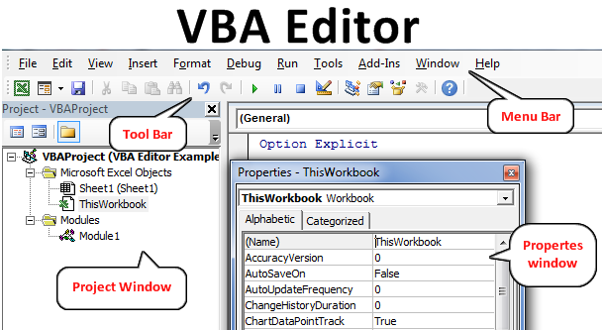

**6.What is an immediate Window and what is it used for**

**The Immediate window displays information resulting from debugging statements in your code or from commands typed directly into the window. From the View menu, choose Immediate window (CTRL+G).**